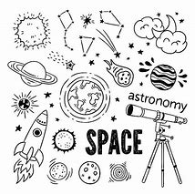
DUE TO COVID OUR MEETINGS WILL BE HELD VIRTUALLY,
OUR WEBSITE IS UPDATED FOR UPCOMING MEETINGS,
OUR WEBSITE IS:
gatewaytotheuniverse.org

Welcome!! To any newcomers enjoy our great Astronomy of
space news and views!! In our new virtual platform
FEES FOR 2020-2021 MEMBERSHIP ARE:
Single fee $30 dollars per year
Student fee $10 dollars per year
Family fees $40 dollars per year

Becoming a member of the North Bay Astronomy Club has advantages. Loaner equipment shown on our website can be borrowed for a month at a time (or longer).

_____________________________________________________________________________________
Don’t forget to:
- Check out our WEBSITE at: www.gatewaytotheuniverse.org
- Also check out our Facebook Group: NORTH BAY ASTRONOMY CLUB as our up-to-date source for info.
- Recently added is our YouTube Channel: GATEWAY TO THE UNIVERSE - YouTube with great videos such as identifying constellations, messier objects, how-to’s and more. Check often we’re always adding more.
Venus As March 2021 opens, Venus sits too close to the rising sun to be visible; and as March 2021 draws to a close, Venus looms too close to the setting sun to be seen. In other words, Venus – in its smaller, faster orbit around the sun – is about to “turn the corner” ahead of us in orbit. On March 26, Venus is to pass on the far side of the sun, to exit the morning sky and to enter the evening sky. That’s when this inferior planet will reach superior conjunction.

Mars Mars resides in front of the constellation Taurus the Bull from now until well into April 2021. Enjoy Mars in March 2021! It’s only going to get fainter as this year progresses. In the months ahead, Mars will slowly but surely dim as – day by day – it will sink closer and closer to the setting sun.

Mercury Mercury, the innermost planet, bunches up with Jupiter and Saturn in the morning sky during the first week of March. Mercury actually has a conjunction with Jupiter on March 5, but his conjunction will probably be difficult to view from northerly latitudes.

Jupiter and Saturn remain fairly close together in the eastern predawn/dawn sky throughout March 2021. Saturn rises first and Jupiter follows Saturn into the sky shortly thereafter. From northerly latitudes, Jupiter and Saturn might still be hard to view in the early part of the month. But they’re there, and, day by day, the planetary twosome will rise sooner before sunrise and appear a bit higher in the predawn/dawn sky. For the best view, find an unobstructed horizon in the direction of sunrise. Seek them out with binoculars first. Toward the end of the month, try seeing them with the eye alone.

Question of the month
What is the weight of Perseverance rover?
Answer in next month’s issue

Newfound Comet Leonard will blaze into view this year
The comet was discovered in January and may be bright enough to see without a telescope.
A new comet is on its way in toward the sun, with prospects that it may become bright enough to see with the unaided eye by year's end. The object in question is Comet Leonard, catalogued C/2021 A1 and was discovered by astronomer Gregory J. Leonard on Jan. 3 at the Mount Lemmon Observatory, also known as the Mount Lemmon Infrared Observatory. The newfound comet C/2021 A1 (Leonard) will make its closest approach to Earth on
Dec. 12, 2021.
An asteroid the size of the Golden Gate Bridge is zooming by Earth on the first full day of spring
An asteroid will whip past Earth later this month — the largest and fastest asteroid to pass close to our planet this year. The asteroid is set to come within 1.25 million miles of Earth at 11:02 a.m. ET on March 21. That's close enough for NASA to classify it as "potentially hazardous" in its database of near-Earth asteroids.
But don't worry, it won't get too close.
The asteroid, officially known by NASA as 231937 (2001 FO32), is about 0.5 to 1 mile in diameter, making it larger than about 97% of asteroids but small compared to large asteroids, according to Space Reference. It has an orbit period of 810 days.
Moon phases
Last Quarter – January 24, 5:20
New Moon – January 30, 21:38
First Quarter – February 6, 19:22
Full Moon – February 14, 23:53

What would the Sun look like from Pluto?
ANSWER: Since Pluto is so far away from the Sun (at a average distance of 3,670,050,000 miles), the Sun would look much dimmer and smaller that it does from here on Earth. From Pluto, the Sun would look like a very bright star and would light up Pluto during the day about as much as the full Moon lights up Earth at night.

We Encourage members/non-members to get involved in star-gazing activity,
We have The Beginners Certificate and Messier Certificate and other Certificates on our website. It gives purpose to stargazing. There are always people to help you along. Good luck and clear skies to all.

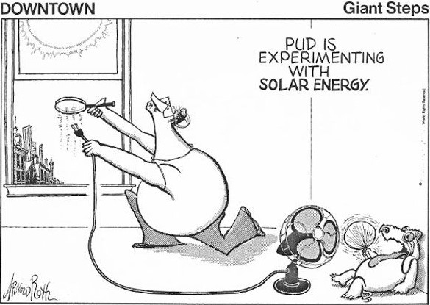
Gilles Beleque has logged 21 of the 25 objects from the Beginner’s Certificate List
Bill Montague has logged 27 of the 65 objects from the Bill’s Finest Globular List
Linda Pulliah has logged 50 of the 110 objects from the Finest NGC’s List
Bob Chapman has logged 1310 of the 2517 objects from the Complete Herschel List
Curtis Irish has logged 3 of the 25 objects from the Beginner’s Certificate List

Congrats to everyone taking part in your beginners certificate or messier list or other list.
On-going Progress with Certs and Lists
E-mail me your progress, let me know how you’re doing, I’ll print it in the NBAC News Letter.
For any inquiries or to update me with your progress my e-mail is: stargazingran@yandex.com

The RASC-Sudbury Centre welcomes anyone wishing to take part in their virtual meetings to send a request to rascsudburycentre@gmail.com
Or many of you know Linda Pulliah you can contact her at pulliah@fibreop.ca
The Sudbury Astronomy Club Meetings are every first Friday of each month at 7:30pm-9:30pm. For full details go to www.sudburyastronomyclub.com

THE SKIES ARE YOURS TO DISCOVER
stargazingran NBAC

