NBAC NEWS LETTER _________ __ MARCH ISSUE 070
Meetings at SILVER BIRCHES PUBLIC SCHOOL 65 Marshall Ave. E, North Bay every 3rd Wednesday from
September to June. Full details and directions are posted on our web page, www.gatewaytotheuniverse.org

Welcome!! To any newcomers enjoy our great Astronomy of space news and views!! This month is Election month exercise your right as a Member and vote.

We have Public Viewing (Friday or Saturdays)
During winter months the parking lot is not maintained so there will be no viewing.

But do:
- Check out our WEBSITE at www.gatewaytotheuniverse.org
- Also check out our new Facebook Group as our up-to-date source for info.

Venus Day by day, Venus spends a little less time in the predawn sky before sunrise with each passing morning, but it’ll still be dazzlingly bright and visible at dawn for months to come.
Mars Look for Mars to pair up with the Pleiades cluster in late March. You may – or may not – need binoculars to see the Pleiades. Watch Mars now because the red planet will fade into a 2nd-magnitude object by early April 2019.
Saturn From mid-northern latitudes, Saturn rises about 2 1/2 hours before the sun in early March. That’ll increase to about 3 1/2 hours before sunup by the month’s end.
Mercury At mid-northern latitudes, Mercury rises less than one hour before the sun in the waning days of March.
Jupiter If you’re up during the predawn hours, you might notice a bright ruddy star in the vicinity of Jupiter on the sky’s dome. That’s Antares, the brightest star in the constellation Scorpius the Scorpion.

CONGRATS, To our February, 50/50 winner Linda Pulliah …………………… !!

Question of the month
Why is the sky blue?
Answer in next month’s issue

Moon phases
Full moon March 20, 2019 06:43:00 PM
Last quarter March 27, 2019 09:11:27 PM
New moon April 5, 2019 01:52:22 AM
First quarter April 12, 2019 12:06:03 PM

FEES FOR 2018-2019 MEMBERSHIP ARE:
Single fee $30 dollars per year
Student fee $10 dollars per year
Family fees $40 dollars per year

Becoming a member of the North Bay Astronomy Club
has advantages. Loaner equipment shown on our website
can be borrowed for a month at a time (or longer).

NBAC NEWS LETTER page 2 __ MARCH ISSUE 070

Answer to last month’s question.

How does a telescope work?
ANSWER: The primary purposes of a telescope are to gather light and magnify an image. The aperture (opening) of a telescope is larger than that of the human eye and therefore, can gather much more light. This enables us to see dim objects that are too faint to see with the naked eye. The larger the aperture of the telescope, the more light it can gather. Telescopes also use a series of lenses and/or mirrors to magnify the image, enabling us to see more detail.

Word of the Month: AVERTED VISION
Is a technique for viewing faint objects which uses peripheral vision. It involves not looking directly at the object, but looking a little off to the side, while continuing to concentrate on the object.

As motivation and encouragement for members/non-members to get involved in star-gazing activity, we have a 5-way challenge on completion of the Beginners Certificate.
The Candidates are as follows: Tom Ouellette, Peter Balen, Clark Smylie, Merlin Clayton and Dave Roscoe. Congratulations on taking this challenge good luck and clear skies to all.

Clark Smylie has completed 4 of the 25 objects from the Beginner’s Certificate List
Linda Pulliah has logged 45 of the 110 objects from the Finest NGC’s List
BOB CHAPMAN has logged 1310 of the 2517 objects from the Complete Herschel List
Curtis Irish has logged 1 of the 25 objects from the Beginner’s Certificate List
Tom Ouellette has logged 23 of the 25 objects from the Beginner’s Certificate List

Congrats to everyone taking part in your beginners certificate or messier list or other list.

On-going Progress with Certs and Lists
E-mail me your progress, let me know how you’re doing, I’ll print it in the NBAC News Letter.
For any inquiries or to update me with your progress my e-mail is: stargazingran@yandex.com

The Sudbury Club welcomes anyone visiting Sudbury or planning a road trip to take part in the Sudbury astronomy meetings at the Doran Planetarium (Fraser Building). The Sudbury Astronomy Club meetings are every first Friday of each month at 7:30pm-9:30pm (unless it lands on a holiday). For full details go to www.sudburyastronomyclub.com

Frozen Banana Star Party May 30-June 2 – Mew Lake Campground – Reserve December 30, 2018
New Moon in June - June 27-30, 2019 – Grundy Provincial Park – Reserve January 27, 2018.
(we will let you know which area of the park we will be in, once we know, however there is always lots of sites available in June)
Gateway - July 25-28, 2019 – Samuel De Champlain Provincial Park Large Group Site. Reservations are not required.
August Star Party Aug 29 - Sep 01, 2019 – at The Chapman’s observing field.
No reservations required, but would appreciate knowing if you will be joining us.
Half the Night Aug 22-25, 2019 Halfway Lake Provincial Park. Reserve March 22, 2019.
Last Chance Star Party - Sept 26-29, 2019. Restoule Group Site , not sure yet. No reservations required.

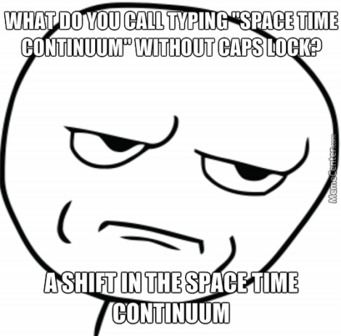

THE SKIES ARE YOURS TO DISCOVER
stargazingran NBAC

